CALL FOR SUBMISSIONS:
Community engagement for inclusive rural transformation and gender equality
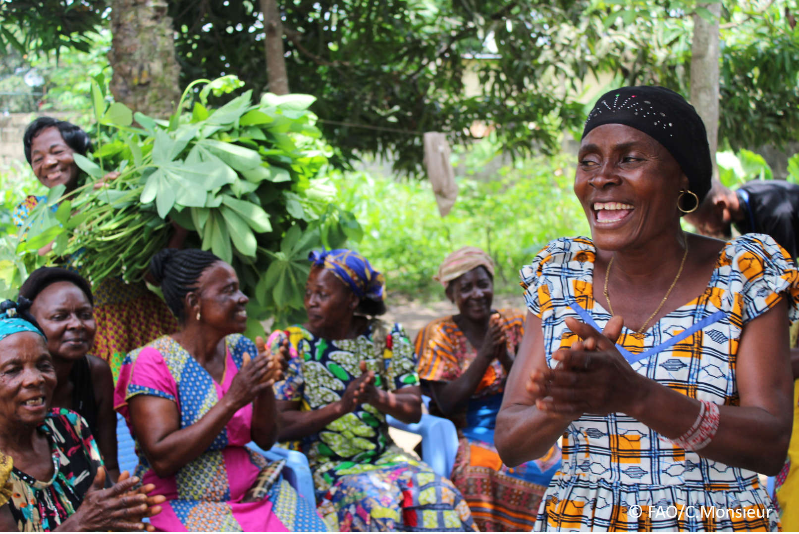
The objective of this call for submissions is to collect good practices, experiences, and lessons learnt on the use of community engagement for inclusive rural transformation and gender equality. The initiative, organized by the Rural Transformation and Gender Equality Division (ESP), seeks to gather insights from a diverse range of contributors, both within FAO and from external stakeholders. Its goal is to share knowledge, foster learning, and guide the scaling up of community engagement and community-led collective action to leave no one behind. The call builds on FAO's past efforts in this area, such as the Community Engagement Days series of webinars.
The call for submissions is open until 27 November 2024.

How to take part in this call for submissions:
To take part in this Call for submissions, please register to the FSN Forum, if you are not yet a member, or “sign in” to your account. Please review the topic note to understand the criteria we are considering for this call. If you wish to learn more about community engagement, you may refer to the background document. Once you have completed this submission template, upload it in the box “Post your contribution” on the call webpage, or, alternatively, send it to fsn-moderator@fao.org.
Please keep the length of submissions limited to 1,500 words and feel also free to attach relevant supporting materials.

Template for submissions

Contact person | Name: Tendai Manyozo  Organization/Unit: Plan International  Country: Global  Email address:  Tendai.Manyozo@plan-international.org
Name/title of the good practice | A Working Future
Where is the good practice taking place? (Multiple selection allowed) | ☐ Europe and Central Asia  ☐ Latin America and the Caribbean  ☐ North Africa and Near East  ☒ Sub-Saharan Africa  ☐ Asia and the Pacific  ☐ North America  ☐ Global
Affiliation | ☒ Farmer and producer organizations  ☐ Trade Union  ☒ Informal community-based, farmer-based or self-help group  ☐ Research and academia  ☒ Government  ☐ Local/traditional authorities  ☒ Private Sector  ☐ Civil Society Organization  ☐ Intergovernmental Organization (e.g. UN system, World Bank)  ☐ Resource Partner/Donor  ☐ Other (please specify)
In which sector(s) and context (s) have you used this community engagement good practice? (Multiple selections allowed) | ☐ Education  ☐ Health and Sanitation  ☒ Food production in agrifood systems (please also tick the sub-categories)  ☒ Crop cultivation  ☐ Fisheries and aquaculture production  ☐ Livestock  ☐ Forestry  ☐ Agroforestry  ☐ Horticulture  ☐ Apiculture (beekeeping)  ☐ Agroecology and sustainable farming practices  ☐ Soil and water management  ☐ Other: ____________  ☐ Post-production in agrifood systems (please also tick the sub-categories)  ☒ Processing and value addition  ☒ Marketing and retailing  ☒ Transporting  ☐ Food loss and waste  ☐ Packaging  ☒ Storage  ☒ Distribution  ☐ Other _________  ☒ Gender Equality  ☐ Climate Action  ☐ Citizenship and Governance  ☐ Social Protection  ☐ Humanitarian and protracted crisis  ☐ Conflict resolution, peace and resilience  ☐ Digital innovation  ☐ Other sector (please specify) _________
Who are the financial partners supporting this good practice, if applicable? | This Project was supported by Plan International Sweden and Plan International Norway
- In a few sentences, summarize your community engagement good practice.
The AWF model supports youth economic empowerment through innovative methods in collaboration with the private sector. The model has its foundation in Village Savings and Loans Associations (VSLAs) to provide increased access to financial services, and use them as a platform to teach critical skills required for youth employment. The youth are then linked to private sector opportunities through different employment pathways, namely (i) micro-enterprise, (ii) micro-franchising and (iii) agriculture producer groups.

The model has been implemented in Uganda from 2012-2016 and 2019-2022, and in Tanzania from 2019-2022. The 2012-2016 project in Uganda and the project in Tanzania promoted all three employment pathways, whereas the most recent project in Uganda focused on the agriculture producer group pathway.

- What problem(s) or challenge(s) does your good practice aim to address through community engagement?
The overall objective of the AWF model is that vulnerable youth, especially young women engage in sustainable and decent work. AWF’s systemic solution offers solutions not only by addressing supply-side constraints of low educational attainment and skills (human assets) as well as access to capital (financial assets), but also works with the private sector to identify profitable market opportunities for youth, and assists in changing discriminating gender norms and institutions to ensure young women equally benefit from capacity development and self-employment opportunities.

- Describe your good practice in more detail. Include the main guiding principles, the desired changes or outcomes you aim to achieve (Theory of Change), and the key phases of implementation.
Overall Objective: Improve young women’s access and engagement in sustainable and decent work.

The specific desired outcomes (from the AWF Tanzania project);
1. Youths' increased access to capital
2. Improved capacities of youth to engage in decent work
3. Increased involvement of the private sector in youth employment
4. A gender-responsive environment and norms that enhance opportunities for girls to transition into and maintain decent work

The model has been tested in implementation time frames of four-five years. The following stages are applied: Stage 0 (month 1-3): Awareness and on-boarding, Stage 1 (month 4-12): Becoming a VSLA – formation and support, Stage 2 (after 12 months): Running a VSLA + Core Skill Building including training and business plan initiation, then identification of optimal pathway(s), matching skills with market demand and business plan presentation, then Stage 3 (from 15-27 months): Employment Pathway Introduction and Establishment

- Establish Micro Retail Market (distributor linkages, identify market, establish market connections)
- Establish Micro Enterprise (small scale commercial activity, focus on quality and productivity improvements, extension support services, mentorship, market linkages)
- Form Youth-Led Producer Groups (small scale commercial activity, focus on quality and productivity improvements, agriculture extension support services, mentorship, market linkages)

and Stage 4 (28 + months): Employment Pathway Acceleration
- SME Development (selected from the Micro-Enterprises, and activities including individual bank accounts, processing and mechanisation, employees hiring, funding support and formalization)
- Producer Group Acceleration (individual bank accounts, processing and mechanisation, bulk marketing and collection centres, funding support and formalization + form clusters of producer groups)

Throughout all stages there is coaching, skills development and continuous private sector assessment. Methodologies used in the agriculture producer groups include Participatory Market Chain Approach (developing innovations along commodity value chains for improved market access) and the Farmer Field Schools Methodology (a participatory method of learning, technology development and dissemination based on adult learning principles developed by FAO).

A phased mobilization and recruitment of youth into groups allows ample time for their establishment and support to become operational during the project period. In Uganda (2019-2022), the project team was sub divided to allow some staff to continue with mentoring of existing groups and VSLA and support their transition into producer groups while the other group mobilized for recruitment of new groups.

In practice, the AWF model may be less linear than described above, as internal and external factors including the nature of the target groups (dropouts, migration, conflict), changes of plans and approaches, policy changes and COVID-19 may lead the projects to move up and down the different stages during implementation (lesson from AWF Tanzania). In the contexts where the model has been applied, there has been limited formal jobs available and most youth have therefore established their own businesses / opted for self-employment. Vocational skills and enterprise development pathway appears most successful in settings in or close to urban areas, whereas the producer group pathway may be the one promoted in more rural areas.

- Who are the key actors and stakeholders involved in the design and implementation of the good practice, and what are their respective roles? Consider local partners, government, local authorities, community radios, civil society, research, the private sector, etc.
- Young people with a specific focus towards young women: Young women are supported to set up and run Youth Savings and Loans Groups. Through these groups they are offered training in several different job related skills, agricultural production and start up capital.
- Private Sector Organizations: These are engaged to offer trainings to young people and also to be resource persons by offering business mentorship, coaching and guidance
- How does your intervention ensure inclusivity and equal and meaningful participation within the community?
Describe how your intervention includes and engages different groups within the community. Consider aspects like gender, age, ethnicity, disability status, livelihoods, and other specific conditions (e.g., people living in prolonged crisis, migrants, refugees). Explain how your intervention engages diverse segments of the rural community. Highlight the specific actions or strategies you use to reach these groups. If applicable, mention if your intervention uses specific approaches such as gender-responsive, gender-transformative, intersectionality, or other methods to ensure inclusivity and gender equality.
During the phased approach of the project, the project engages women as recruiters, mentors and business partners. This is aimed at encouraging other young women to attend and participate in the program by providing safe spaces for them to ask questions, express themselves and engage. In addition to this, at each stage of the project, there were awarenessa campaigns and messages targeted at different groups within the community, one of which is young women with disabilities. These messages were directly targeted at these women to demonstrate to them that the project is for them and that it has mechanisms to support them through out the process. Due to this, the project has had several young women with different physical disbabilities join and graduate.
- By using community engagement, what results and impacts have your good practice achieved?
Please provide specific examples and evidence demonstrating the effectiveness of your intervention, focusing on both qualitative and quantitative outcomes related to livelihoods and well-being improvements.
Youth Savings and Loans Associations (YSLAs) have contributed to an increase in the number of savings, borrowing, and investments in productive businesses. The MIS-SAVIX report of 2022 also revealed a significant improvement in YSLA groups' savings, which was up to 312% compared to the project target of TZS 36,000,000 (NOK 161,460.00) set in 2019. This shows that the YSLAs have played a significant role in promoting financial inclusion and economic empowerment among young people. Further to this the YSLAs have contributed to several factors, including an increase in confidence among the youth to lead and establish self-employment, take investment risks, and explore employment and market opportunities within their localities. Additionally, changes in behaviour, such as the community’s perception towards the role of women in economic activities which was addressed through awareness sessions on gender transformation interventions, have also contributed to the increase in the capacity of young women to save, borrow, and invest in businesses. It is also important to note the impact of the YSLAs extends beyond the economic benefits. The group has also supported youth to attend to social needs through the social fund contribution.

In addition to this, the project has linked YSLA with the financial services providers using their savings as collateral for accessing loans. Through close collaboration with financial institutions, 25% (56% female and 44% male) have managed to receive loans from financial services providers including FINCA Microfinance Bank, Tanzania Commercial Bank (TCB) as well as specific loans set aside for youth from the local government authority funds. These loans have been used to establish new businesses, strengthen existing business operations, and meet other social needs. Additionally, in 2022, YSLA groups consisting of 54 members living with disabilities (29 female and 25 male) secured a loan of TZS 21,000,000 (NOK 94,185.00) from the government and purchased seven motorcycles for business. Also, seven business groups with a total of 42 members (29 male and 13 female) received a loan from SIDO amounting to TZS 15,000,000 (NOK 67,275.00). The success of these individuals and groups in accessing loans indicated that YSLA is providing financial assistance to youth and promoting entrepreneurship. To achieve all this the project has linked all 58 YSLA with banks and microfinance institutions, resulting in 53 groups reporting to having active bank accounts. The collective bank and mobile banking savings of 53 groups amount to TZS 53,923,300 (NOK 241,846.00), with an average bank saving per group being TZS 929,712 (NOK 4,169.76).
- Among these results, has the good practice led to improvements in terms of gender equality, women’s empowerment, and/or social inclusion?
Describe the behavioral changes in terms of gender that the good practice promotes, emphasizing agency, leadership, and participation in local governance. Include efforts to challenge discriminatory norms and unequal power dynamics. Highlight also how the intervention has supported the well-being (including psychological resilience) of marginalized groups and enhanced their inclusion and participation in decision-making processes.

The project has contributed to an improvement in how the community view women, including women with disabilities and their ability to participate and compete successfully in the job sectors.
- What key challenges did you encounter while implementing the community engagement activities, and how did you address them?
Include any resistance from communities, pushback, or issues related to unequal power dynamics, if applicable.

- The AWF model does not follow a linear progression pathway, the project was moving up and down during the implementation. The movement was caused by different factors (internal and external), including the nature of the target groups (dropouts, migration, conflict), ongoing changes in project design, plans, and approaches, policy changes including the new Microfinance Policy, COVID-19, etc. All these changes caused ups and downs movement.
- Most youths in the age range of 15-17 were considered minors; therefore, they could not be engaged or matched with formal employment opportunities. This age group also has little saving abilities as they were mostly dependent on family members, resulting in less control of the savings and investment decisions. Youth in this age group cannot open bank accounts as they are considered underage and do not hold relevant IDs. Therefore, improved interventions need to be thought through to support these target groups.
- The burden of unpaid care work was heavily felt by young women. It reduced the participation of young women heavily.
- What are the key lesson learned from your community engagement good practice?
- Has this practice been replicated in the same context or in different contexts?
What are the required conditions to replicate and adapt the practice in another context/geographical area?
The model has been implemented in Uganda from 2012-2016 and 2019-2022, and in Tanzania from 2019-2022. The 2012-2016 project in Uganda and the project in Tanzania promoted all three employment pathways, whereas the most recent project in Uganda focused on the agriculture producer group pathway.

- How sustainable are the results achieved by this good practice?
Describe the key elements that need to be in place to make the initiative sustainable, including enabling environment (legal and policy frameworks and institutions), local ownership, accountability, etc.
Financial literacy is essential in any youth programming. Informal savings groups were a great platform for financial inclusion, specifically for youth and young women. Youth who received proper training managed well their finances and capitalized on products and services offered in the formal financial sector. To achieve meaningful changes and impact, the government, financial service providers, and other stakeholders need to develop financial products that meet the needs of young people. The banks should also strategize and narrow down their focus and reach to the people in rural areas. Skills development is vital for youth engagement in self or wage employment. Skills alone without supporting mechanisms like coaching, mentorship, and start-up tools cannot help youth to navigate the employment world. Youth graduates from SIDO have demonstrated great success after receiving the support of production space, linkages, and training on business development, networks, mentorship, and coaching. Modern and well-managed agriculture production is a potential area for youth engagement in self-employment. High productivity and quality produce from youth demo plots have increased youth interest and motivation to engage with horticulture farming. Some group members were attracted to adopting technologies used in their demo plots and expanding the production base. Due to COVID-19, the pool of private sector actors willing to take youth for internship or employment has reduced, especially for VETA graduates who depend much on private sector actors for job placements. Therefore, the project has decided to support VETA graduates by establishing VET hubs in their respective wards and equipping the centres with the tools needed to perform the job

Upon design and planning for the projects, consideration should be made to include the support costs associated with the provision of childcare services, translation services, and other necessary services. This was observed to be one of the key factors that influenced the greater participation of young mothers and youth with disabilities.

- Based on the conversations FAO held during the Community Engagement days, a definition of community engagement for empowerment was proposed:

“Community engagement for empowerment and community-led collective action can be defined as an inclusive and participatory process that enables community members to become active agents of change in decisions affecting their lives, health, and environment. This process develops their capacity to achieve sustainable outcomes for improved rural livelihoods. Embracing a rights-based approach, it prioritizes the agency and participation of all community members, regardless of gender identity, sexual orientation, age, ethnicity, caste, socioeconomic status, political affiliation, migration status, or ability/disability. Indeed, inclusive approaches recognize the complexities of overlapping marginalization and discrimination that can exclude different community members from decision-making processes and implement strategies to foster their participation, agency and empowerment.”

We invite you to contribute to this definition. What would you add or change? Please share your thoughts, suggestions, and any additional elements you believe are crucial for a comprehensive understanding of community engagement approaches aimed at community-led collective action for inclusive rural transformation, people’s empowerment and gender equality.
\
- Based on your experience, what gaps or areas for improvement still need to be addressed in the field of community engagement?
One area that could be improved is the use of local knowledge, tool, methods, languages and systems that are already existing in communities. Often the voices of us as practitioners become louder than community voices. Local tools are often not fully explored or discussed.
- What do you think is FAO's role in the field of community engagement? How can FAO support and enhance interventions like yours, if applicable? Consider aspects such as policy advocacy, capacity development, funding, technical assistance, knowledge production and sharing, and fostering partnerships.

Link(s) to specific references about your good practice (e.g. reports, communication products, videos, articles) | Please include attachment(s) or add here link(s) to documents/videos/podcasts/other with specific references.  A Working Future Project in Mwanza.

The call for submissions is directly aligned with the thematic components of collective action within FAO's Programme Priority Areas (PPAs), specifically Better Life 1 (Gender Equality and Rural Women’s Empowerment), Better Life 2 (Inclusive Rural Transformation) and Better Life 3 (Agriculture and Food Emergencies).

